# Usability & Accessibility Audit of Okanogan County Electric Co-op.

<http://www.okanoganelectriccoop.com/>

Okanogan County Electric Co-op supplies electricity to some of the rural communities in Okanogan County ([Wikipedia](https://en.wikipedia.org/wiki/Okanogan_County,_Washington)). Focused on the Methow River Valley ([Wikipedia](https://en.wikipedia.org/wiki/Methow_River)), it provides service to the towns of Mazama and Winthrop, along with some residents of the Twisp River Drainage. To accomplish this, it owns 500 miles of electrical distribution lines. The co-op has approximately 3000 members, about half of which live locally and half of which have second homes here.

## HTML: Fail

To check the site’s html code for errors, it was run though the W3C’s HTML Validation Service:

<https://validator.w3.org/check?uri=http%3A%2F%2Fwww.okanoganelectriccoop.com%2F&charset=%28detect+automatically%29&doctype=Inline&group=0>

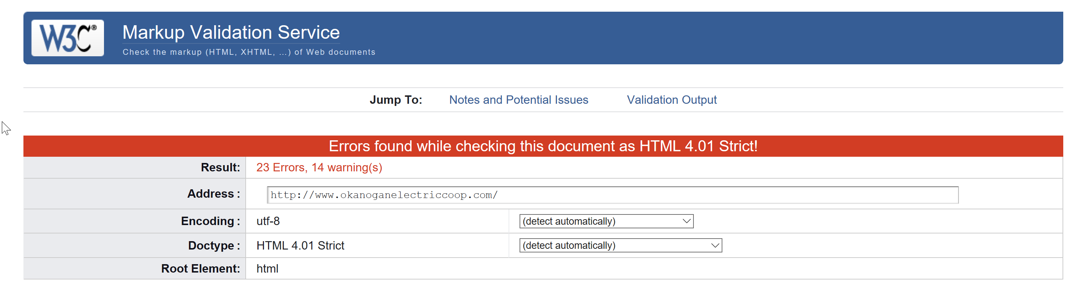

There are many issues with the HTML code in the co-op’s web site, first of which is that it’s not HTML 5. To resolve this, a complete overhaul of the co-op’s web site would be required. This would allow the site to be usable by mobile devices (as opposed to the current situation where the mobile site is highly stripped down, intended for emergency announcements only), and include improved accessibility to co-op members with visual impairments.

That said, within the code are several syntax errors that can cause unpredictable behavior or formatting depending on the browser used:

1. Multiple Unique id’s:
   1. Lines 46 and 90 have list elements that share the same unique id attribute (menuClick7). A simple solution is to give the list attribute on either line a unique id, and then add that id to the CSS Style page. That said, a more complete solution would be to add a shared class attribute that all of the links share for styling, something that will be discussed below in the CSS section.
   2. Lines 44, 71, 103, 138, 144, and 148 all have web link elements that share the same unique id attribute (CURRENT). As this id isn’t referenced anywhere in the CSS style page or the JavaScript page, these id attributes should be removed from all links.
2. The site is designed around a large single frame, with a top menu above, along with column lists to the right and left of the frame. Since frames are problematic to use with touchscreen devices, their use is generally to be avoided when possible. That said, there are issues with this implementation on this site:
   1. Line 63 where the iframe element is defined, has numerous invalid attributes because of the page being coded in strict HTML. These attributes are:
      1. id
      2. src
      3. width
      4. height
      5. frameborder

As such, it is up to the individual browser to decide how to interpret and render the frame, with no guaranteed consistency as to how to display the frame to users. The best solution would be to redesign the site to not use frames. However, if frames are required, implementation of HTML 5 could ensure consistency across all computer browsers as well as some mobile browsers.

* 1. By having menu column lists on both sides of the frame, using smaller web browsers windows, either due to a low-resolution display or because of tiling multiple windows/programs at the same time, can cause the page to become unusable as the content of the frame shrinks and covers up the navigation menu. To fix this, the side columns should be condensed to just one side, with the possible use of fly-out menus, or even a complete redesign of the flow of the page.

## CSS Style Sheet: Fail

To check the site’s CSS style sheet for errors, it was run though the W3C’s CSS Validation Service:

<https://jigsaw.w3.org/css-validator/validator?uri=http%3A%2F%2Fwww.okanoganelectriccoop.com%2Fmain.css&profile=css3svg&usermedium=all&warning=1&vextwarning=&lang=en>

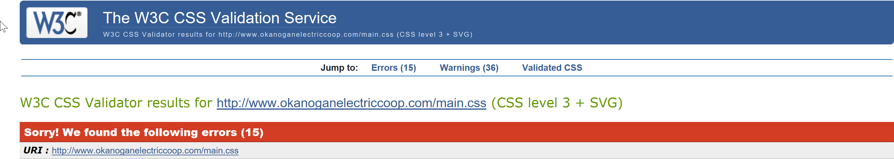

The biggest issues with the CSS style sheet were not any errors per say, but a poor design implementation adding substantial bulk to the sheet, making for slower page loads, larger downloads, as well as increased time and difficulty for future site updates:

1. On the final 6 lines of the CSS style sheet (lines 1158-1163) is code for using a special font for the primary frame on the homepage. These 6 lines of code account for 63% of the code on the CSS Style sheet which can be eliminated by using a standard font, yet still doesn’t account for the font itself having to be downloaded. A far better solution is to use web safe fonts that are already built into web browsers.
2. Due to each of the links in the three menus having their own id attribute, each link has its own style code in the CSS style sheet that accounts for 184 lines of code. If all links shared two class attributes or combinators of elements, this could be reduced to 8 lines.

In addition to these two issues, there were actual syntax errors in the CSS style sheet:

1. 9 different lines have invalid font-weights. If specific font sizes are required, they should be set for these lines. If the default font sizes are OK, they should be deleted.
2. Line 357 contains a hex color code that is formatted improperly. The line reads *color: 3D3D3D;* but should read *color: #3d3d3d;*

## PageSpeed: Pass for Desktop, Warning for Mobile

To check how fast the site loads, it was run though Google’s PageSpeed Insights:

<https://developers.google.com/speed/pagespeed/insights/?url=http%3A%2F%2Fwww.okanoganelectriccoop.com%2Findex.html&tab=mobile>

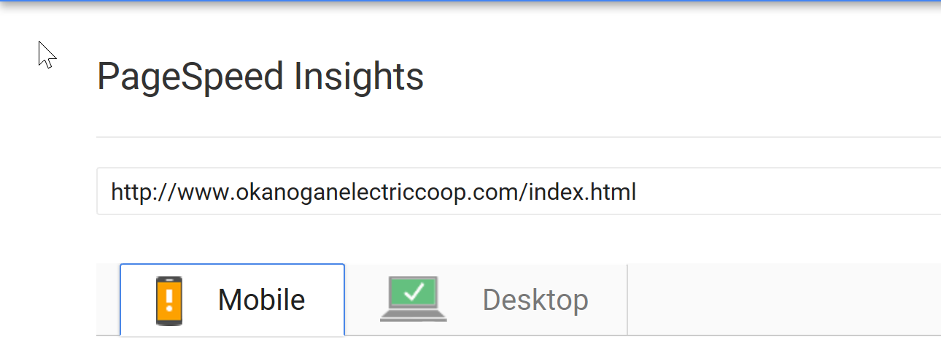

While the desktop version passed, the mobile site passed with a warning. That said, the PageSpeed tool did note that:

*Statistics show that the median page on the internet requires 4 render-blocking round trips and ~75 resources (1MB) to load. But this page appears to use fewer resources. PSI estimates this page requires 2 render-blocking round trips and 16 resources (0.3MB) to load. Fewer round trips and bytes results in faster pages.*

One possible solution, while not recommended, would be to use a sperate CSS file for the mobile site since it uses a completely separate web page with a completely different style. Ultimately, it should be the goal of any redesign to allow mobile users to have access to the full functionality of the site, as opposed to just a few emergency notices. While this might cause the mobile site to load slower, if the CSS was further optimized it could help balance out the increased load times.